MocK NEA

Aadam Imran

Candidate Number: 6409

Learning Centre: Luton Sixth Form College

Contents

Specification: 2

Research: 2

Client/Stakeholder: 4

Features of the proposed solution: 5

Design: 6

Top Down design: 8

Implementation: 10

Testing: 26

Evaluation: 27

Specification:

This project scenario was chosen due to my knowledge of how to explain the wonders of the world. I knew that I would be able to add lots of information about the areas that would be useful for a real website in that scenario as the website would be used by the stakeholder to book tours for these locations so that students 2would be able to book affordable tours for these places and provide feedback to the stakeholder. This project would allow me to have to learn about different areas of web development such as databases and the creation and stylising of a website. The website that I would create would have to consist of at least 8 web pages that would have to be linked together via hyperlinks. The website would also have to consist of a connection to a database using SQL so that the results for the prices of different tours and other factors could be sorted and searched by the user. The first webpage would consist of either a landing page or as a background to the project and the following seven or eight pages would consist of pages about the wonder and the prices of tours for it. Then the final page could be a feedback page or a checkout page. The landing page could be a synopsis of the different wonders offered and there could be a navigation bar that would allow them to navigate between the different webpages. The aspects of the website could be created with plain HTML, CSS and JavaScript and hence no external systems would be required for the layout and most of the interactivity of the website, however the systems needed to connect the website to a database would require the use of PHP to connect the website requests to a MySQL database. The type of database that could be used could be a relational database as such a relational database would allow the tracking of the prices, dates, locations with the use of primary keys such as an ID number that could be unique for each user of the website.

# Research:

Many websites exist that serve the same purpose as my proposed website as the concept of online shopping for tours and trips has existed for many years. Hence many websites exist for such things. TUI is an example of this as they provide flights and packages for holidays which is incredibly similar to what is offered here. 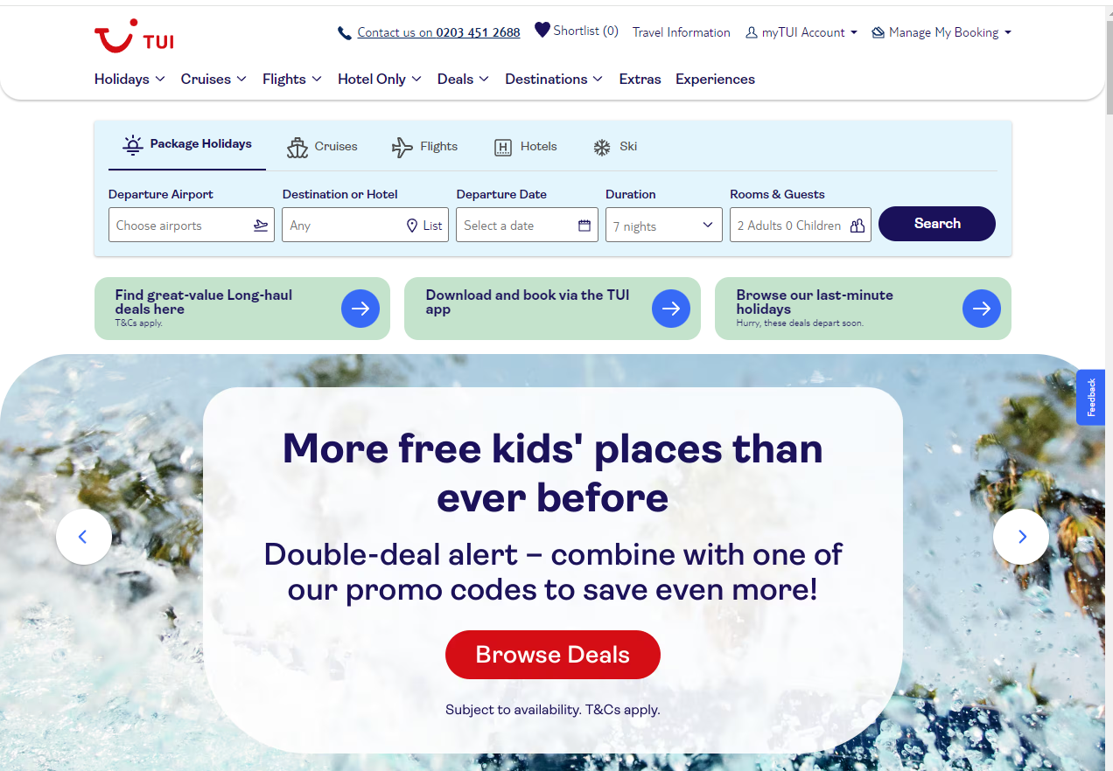

The TUI website immediately can be seen as being too cluttered and hence the user could become overwhelmed by the sheer number of choice. A desigm choice of the website is that the top of the webpage has an are where the user can interact with the database and see if any flights or packages exist for theiir speciific needs. This interaction is useful for pulling the user. The landiingpaage has many buttons and links which would allow a user to interact with lots of parts of the website but this could be detrimental to the User experience. There is no proper colour scheme to the TUI website which does not convey a professional attitude and also does not create a lasting impression on thhe consumers of the website. The impression on the consumer by the website can create a customer that will come back time and time again. The TUI website has many complexites that would introduce a large amount of extra code as the large amount of elements on the website would each require atleast a few lines of CSS and HTML. The many buttons that exist on the website introduce a large amount of javascript needed to add interactivity. The approach that the website takes is only suitable in certain circumstances as the menu to book a trip is very useful and allows the users to book a trip very easily with many options to choose from, the menu is essentially an interface to interact with a database as the menu acts a wrapper for each of the fields in the database which hence allows the end user to search the database. However the website does not provide information on the locations that it offers and hence requires that the users already know where they would like to know.

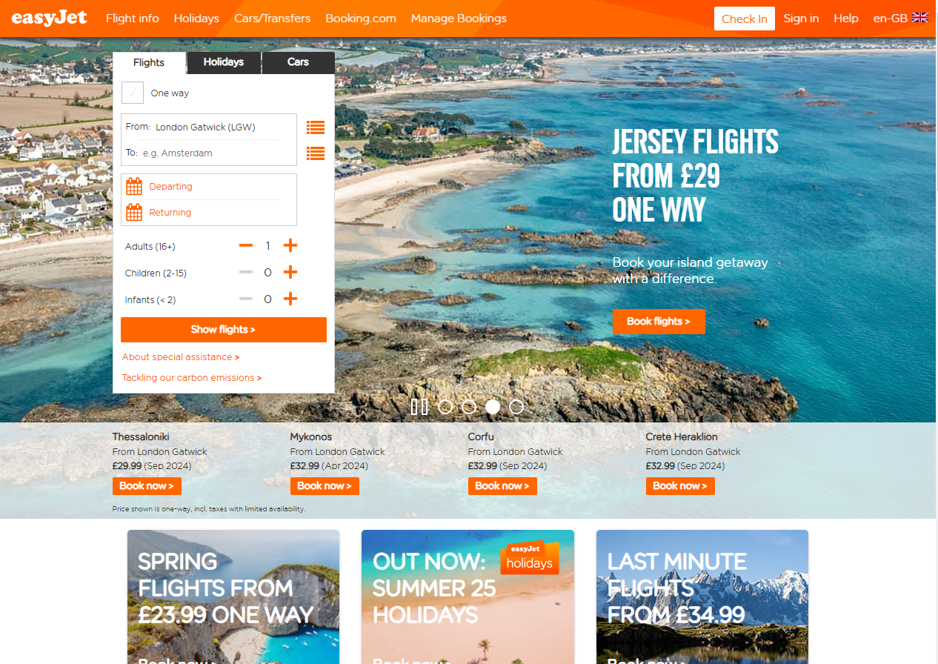

The easy jet website has many of the same problems as the website can feel cluttered to a user and hence put them off using the website. The website allows the user to change the language which is very useful to pulling in more users as they would be able access the website properly. The colour scheme of the website is consistent and therefore pleasing to the eyes which is an important element of any website as it will portray the professional attitude of your company which hence increases the trust that consumers that will have towards you. The website tries to make itself seem appealing to the end user by showing the deals that the user could be enticed by. The website has a menu front and centre that allows the users to find trips according to their specifications, this menu is essentially just a wrapper over a database. This abstraction over the database allows the end user to search the database with their specific search terms.

# Client/Stakeholder:

There are a large number of stakeholders as a travel website for world-renowned sites would harbour the interest of many people. One major stakeholder would be tourists as a website dedicated to the booking of trips to major landmarks and tours of such places would be in the interest of tourists who would want to get more information on the places that they would be visiting. Another stakeholder could be a travel agency as such a website that could be used to direct people to such agencies and hence would direct more customers to them, hence increasing sales. The tourists would prefer that the website would give them information about the locations that they would be travelling to allowing them to learn about places that they could go to and provide them the links to several places where they could book a trip, though it would be in the best interests of the tourists to allow them to book the trips on the website, this could be made by creating an abstraction layer over a database. This could be done by using PHP to link the input areas to a MySQL database. If an organisation such as a travel agency was to be a major stakeholder of the website it would be optimal for the website to direct the user to the travel agency for the booking of the trip.

# Features of the proposed solution:

The solution that I am proposing has some of the features of the websites that I researched and some of my own features that were not present in the websites that I researched. What I took from the websites I researched is a navigation bar that would allow the user to easily traverse the website without having to delve deep into menus. One feature that I wanted to implement myself was an explanation of the places that were offered on the website. These explanations would come in the form of an unordered list of facts that gives an overview of the area and when the user traverses to any of the information pages they can find a paragraph on the area, so they can gain a broader understanding of the area that they are interested in. There would be tables in each information page to show the travel itinerary for each trip. The nature of the website would require the connection to a database, but the scope of this project does not implore me to have to learn PHP to connect the website to a MySQL database.

# 1st iteration of homepage designDesign:

Third iteration to fourth iteration of homepage design

First iteration of homepage design

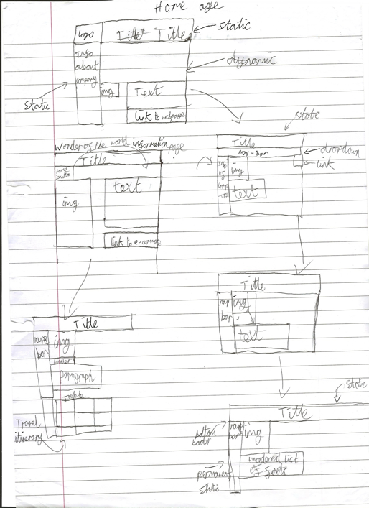

Second iteration of homepage design

The design of the website had to be drawn out before hand as a straightforward design had to be made and hence expanded upon for the end result of the website. The initial design of the website that was drawn had a static title on the top of the webpage with a side static element that would contain the information about the company. In this design there would be the company logo in the top left corner. All the aforementioned elements would have been static and would not move when the user was to scroll the main body of the homepage. The scrollable body of the homepage would have been a collection of similar layouts for each wonder of the world that was to be talked about. The basic layout for each of the element groups was an image that would be left justified whilst the text used to describe that element and the link to the corresponding webpage was to be located beneath the text.

From this original design the only parts that would be retained would be the static title and the static sidebar, although the contents of the side bar would not remain solely the information about the company. The next iteration of the homepage included a nav-bar below the title for the user to navigate with. This navigation bar would have been a dropdown menu which was something that was not retained in further designs. The logo was dropped from this design and would not return in later designs. The text describing the wonder of the world was relocated to be located underneath the image of that wonder. There was going to be a link to the corresponding webpage in the top right of the local body.

The final iteration of the homepage design still contains the static title and navigation bar. However, at this point in the design phase the navigation bar was located in the same space where the former information about the company was to go. These two were conjoined into one static side bar. This would simplify the design of the website and reduce the clutter of it. Since the navigation bar was moved to a permanent location, there was no longer a need to have a hyperlink in the body of the webpage itself, this overall simplifies the website. The images and the text remained in the same location from the previous design.

First iteration of the information page design

Final iteration of the information page design

The information pages of the website went through fewer iterations of design as the overall design of everything bar the body was already designed in the homepage as the navigation bar and the title would remain static in every webpage. The body of the initial design of the information pages separated the image and text on opposite sides of the body of the webpage. In this iteration, a home button was placed in the top left corner of the body, however this home button was later subverted by the navigation bar although the home button could have been used to implement the navigation bar.

The final design for the information websites was more geared towards information about the trip offered to each wonder of the world. Hence, the body of the webpage would now include headers to discern the differences between the paragraphs of information. In this new design of the information pages a table would be created to show how a travel itinerary of a trip would look like. This would be implemented with a simple HTML table which could be decorated with CSS. The use of headers was done to improve the layout of the website and the to improve the user experience as it would allow them to distinguis between what the paragraphs of information were meant to signify.

# Top Down design:

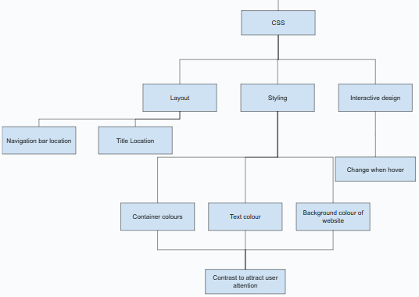

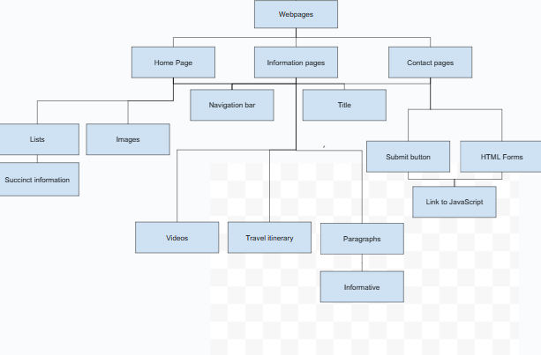

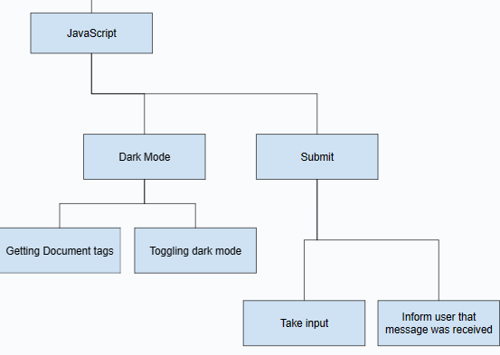

I separated the top-down design of the website into five component parts, the homepage, the information pages, the contact page, the styling of the website and the interactivity of the pages with JavaScript. This separation of the website into its core components allowed me to decompose the problems of the website into smaller chunks. These smaller chunks allowed me to hone in on the problems themselves without initially having to worry about how they would interact with the broader website until all the elements had to be brought together. The four categories are based upon the different areas of problems that had to have my attention. The homepage, information pages and the contact page were all similar in nature as they were just how the HTML would be laid out. Some of the aspect of each of these three sections were the same as the layouts of the title and the navigation bar would be the same across all the webpages. The main difference between these classifications is that the content of the webpages would be different information that will be stored on these webpages, for the homepage unordered lists were the main purveyor of information in that webpage. For the information pages the content on those pages was to be conveyed with paragraphs, tables and embedded videos. These webpages can be seen as having the most components to them due to the sheer number of elements used. The contact page only required the use of some HTML forms and so not much could be done to decompose this page even further. The style decomposition was most complex as the designs for the webpages all required at least a bit of CSS for each element and hence each element had to be considered for the decomposition. The JavaScript decomposition is split into two main parts, the dark mode toggle and the submit function. These two parts were the two parts of JavaScript that had to be done for the website. The dark mode toggle would be shared amongst all the webpages by linking the JavaScript file to all the webpages. The submit function would be located entirely within the contact page within the script tag as this was the only page that would take in input from the user. The style of the website can be seen to be made to create contrast in areas where the user’s attention should be directed. The use of lists in the homepage and paragraphs in the information pages was made to ensure that the stakeholder would gain a rudimentary information when in the homepage as not to overload them with information all in one page.

# Implementation:

Home Page: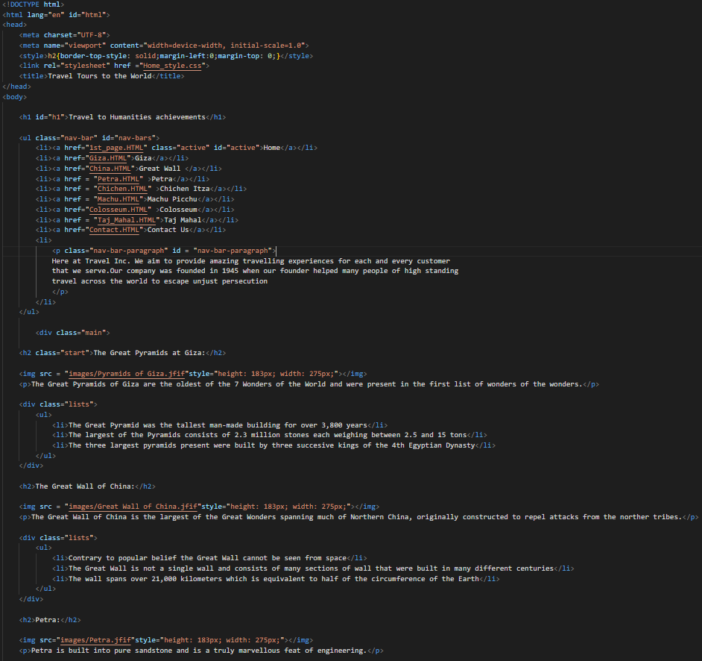

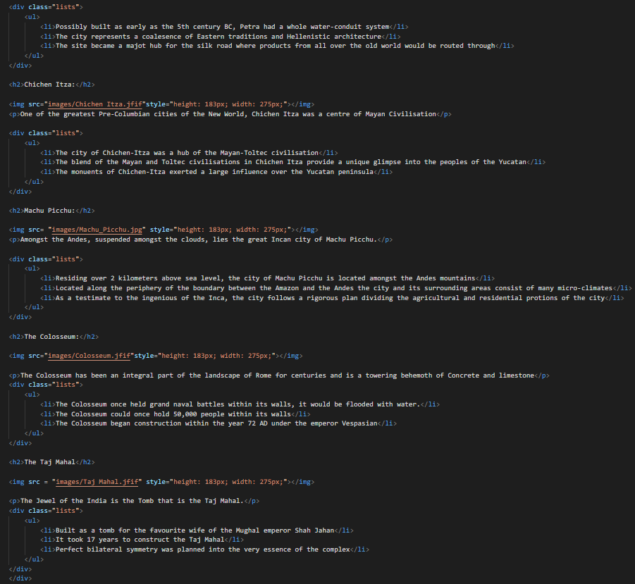

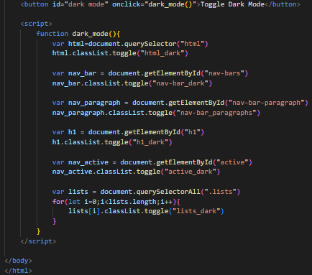

CSS code of Home page:

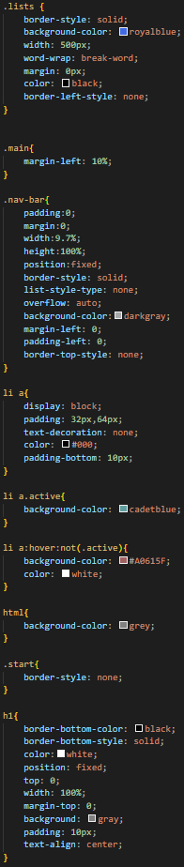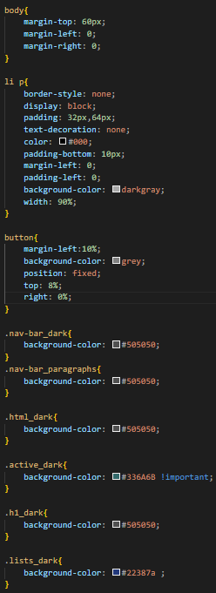

One of information pages as all share similar style:

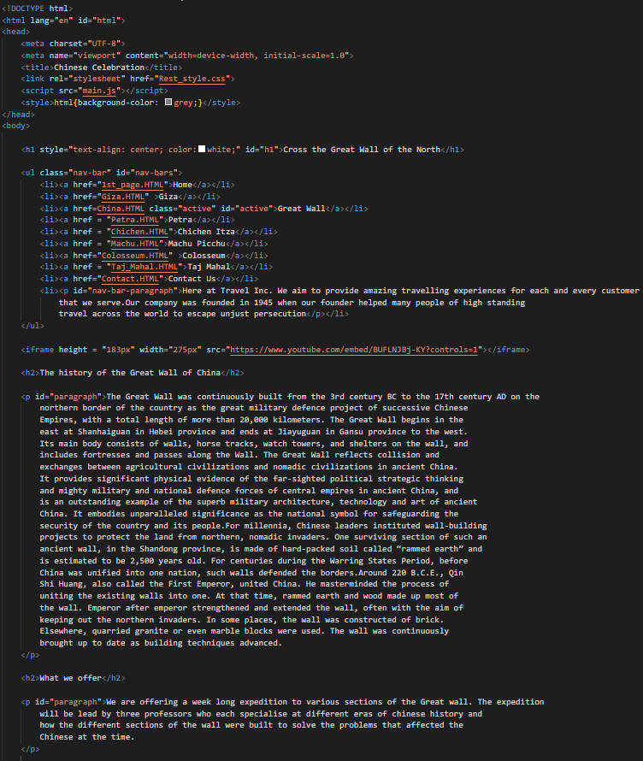

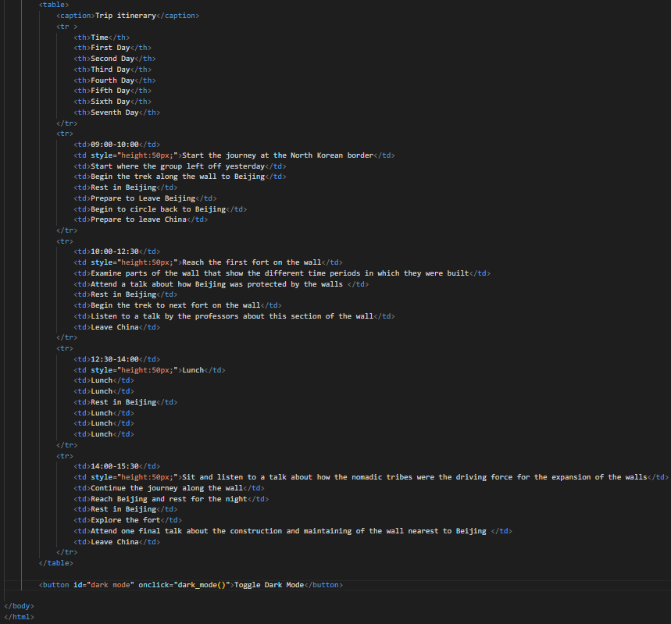

CSS for all information pages:

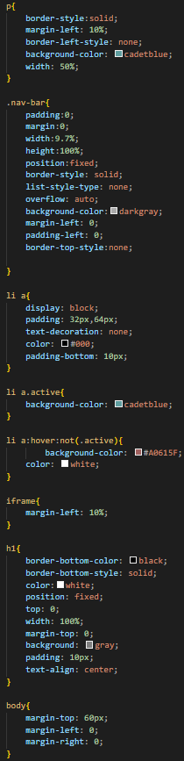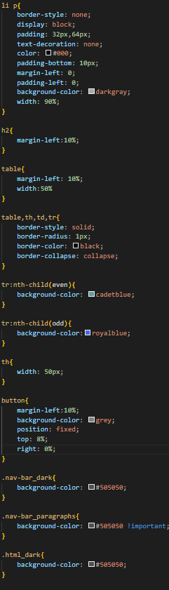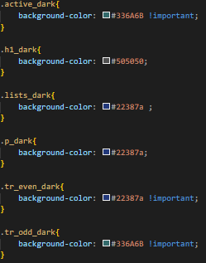

Contact Page:

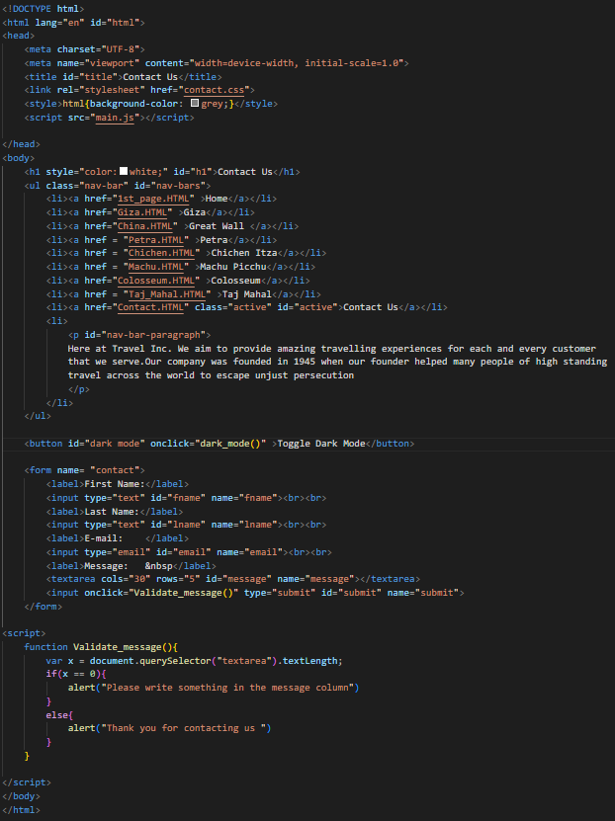

CSS for contact page:

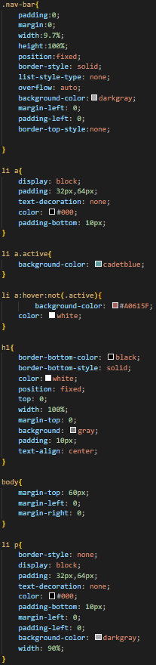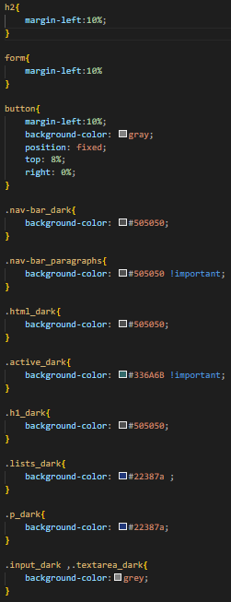

JavaScript File:

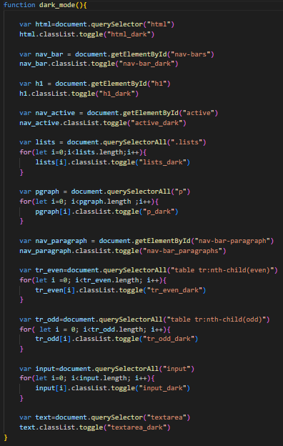

Home page (big page so only top shown as rest is similar):

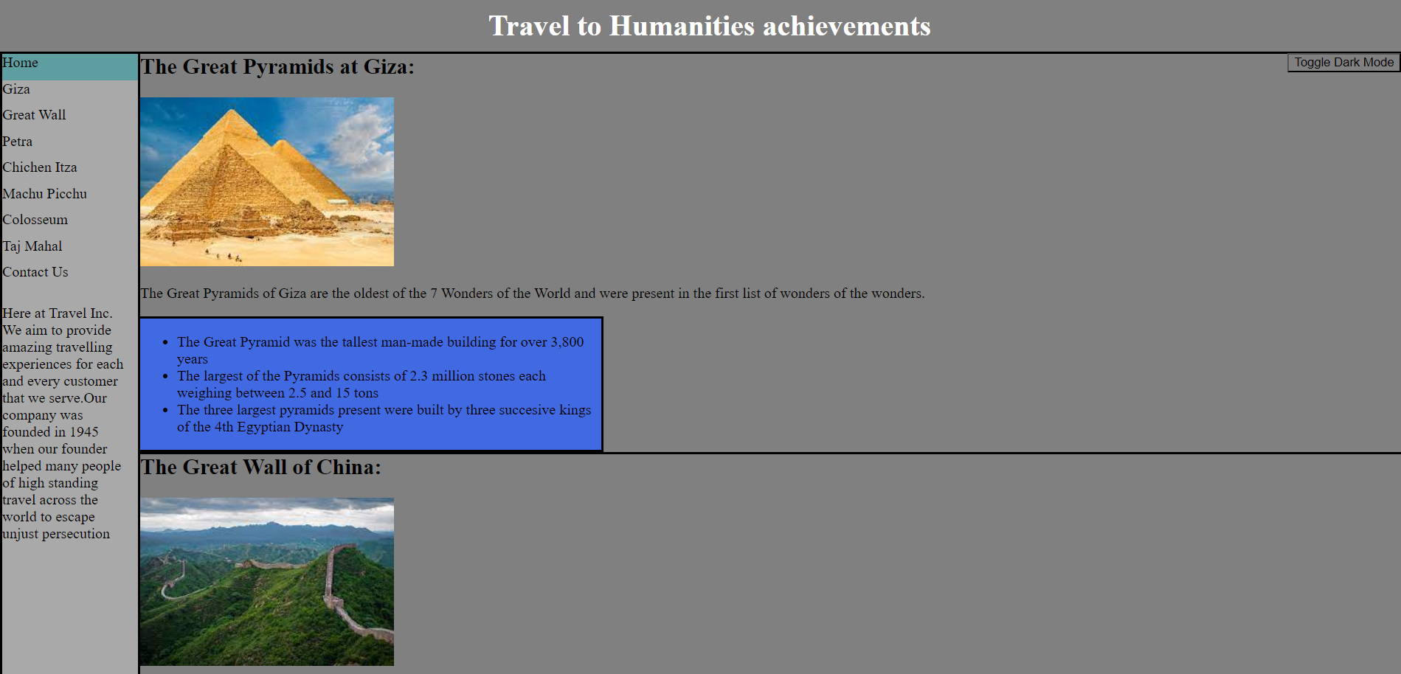

Home page (with dark mode on): 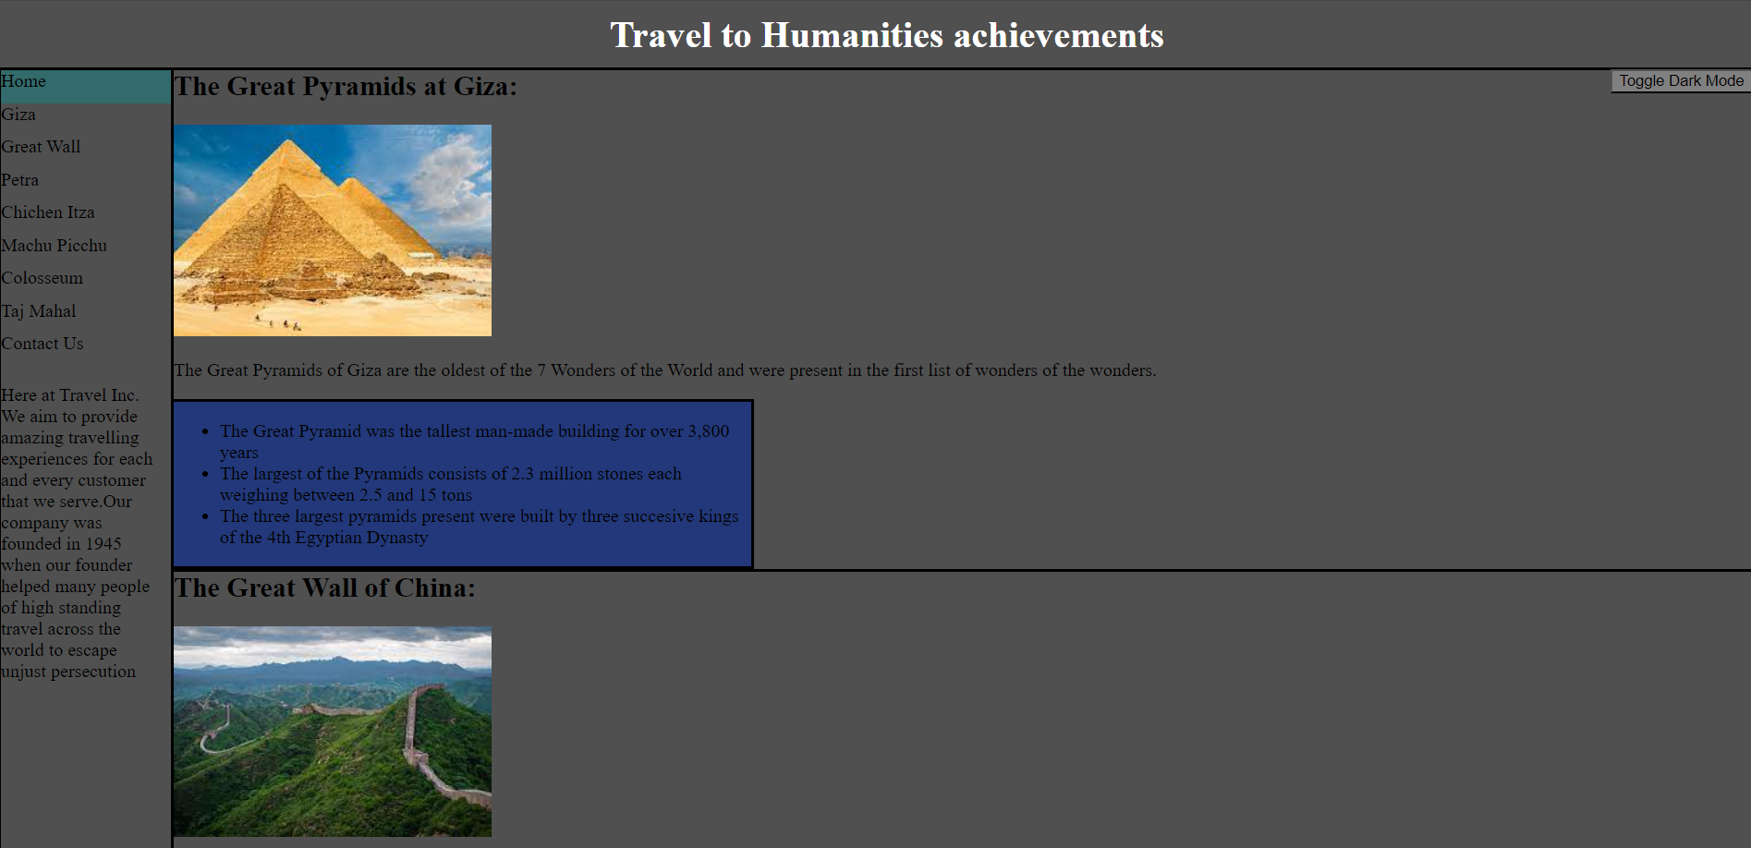

All further pages will have dark mode on:

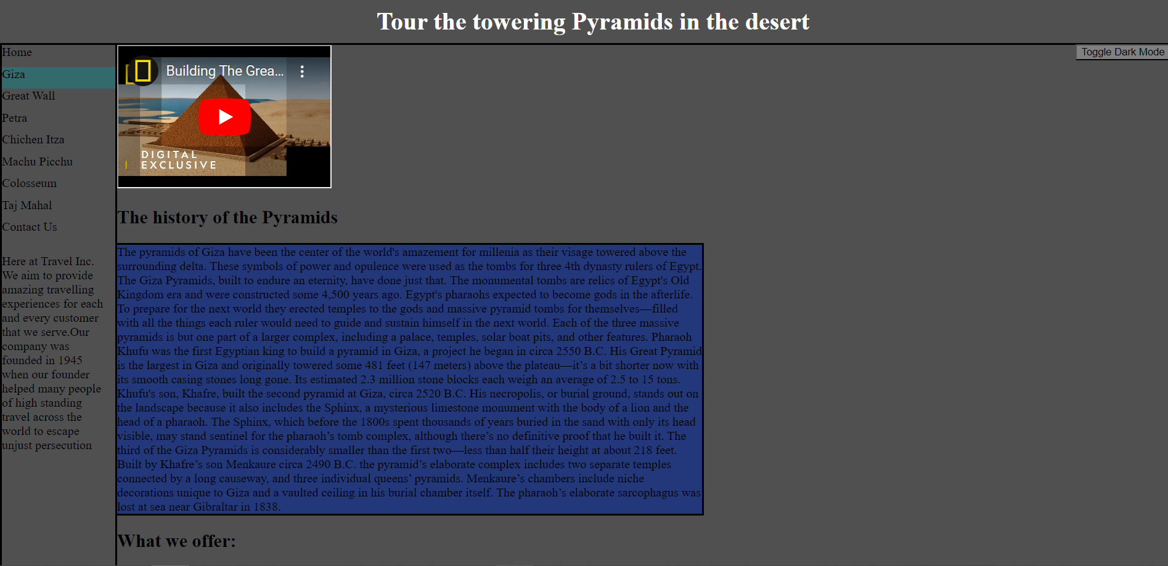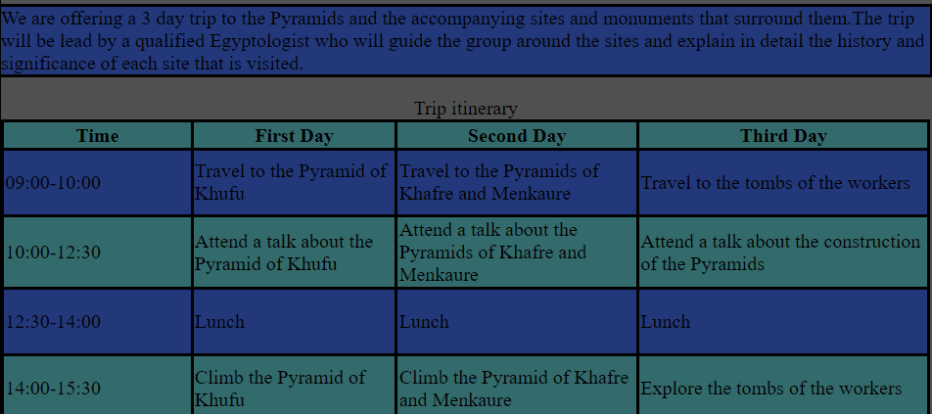

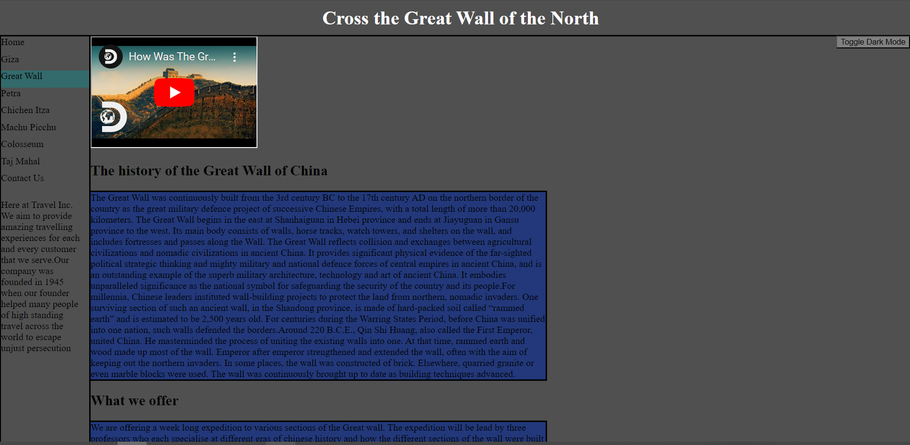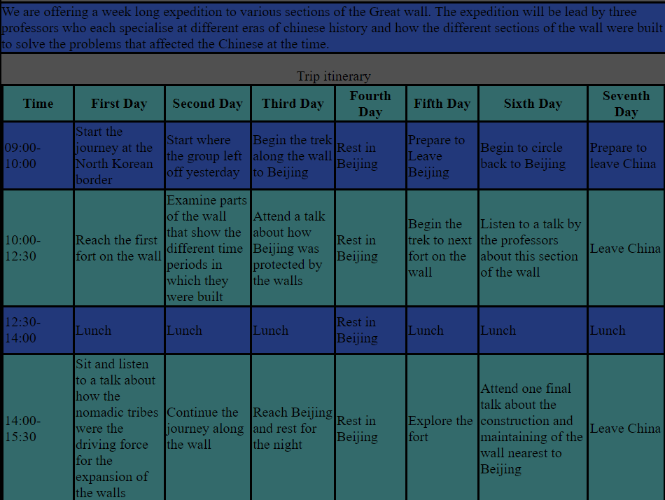

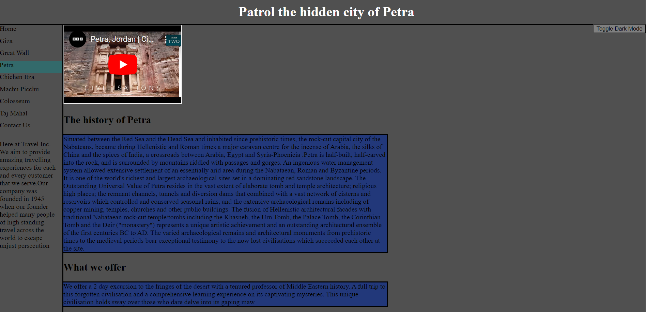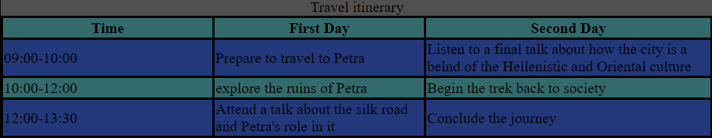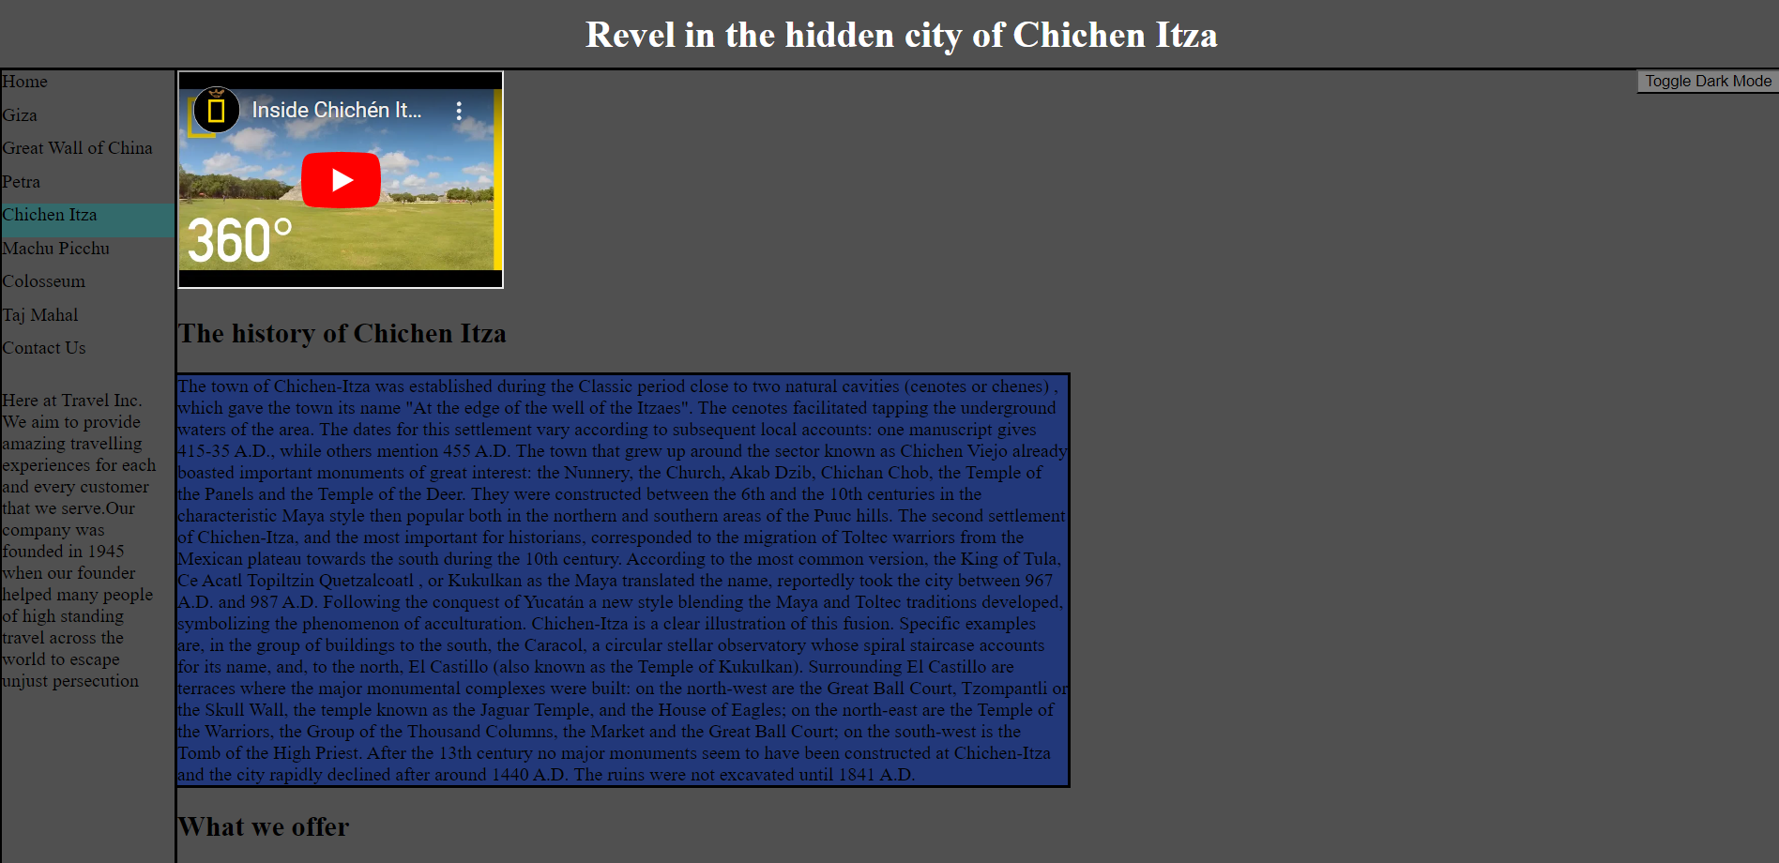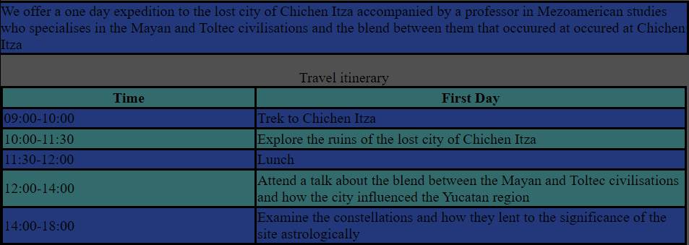

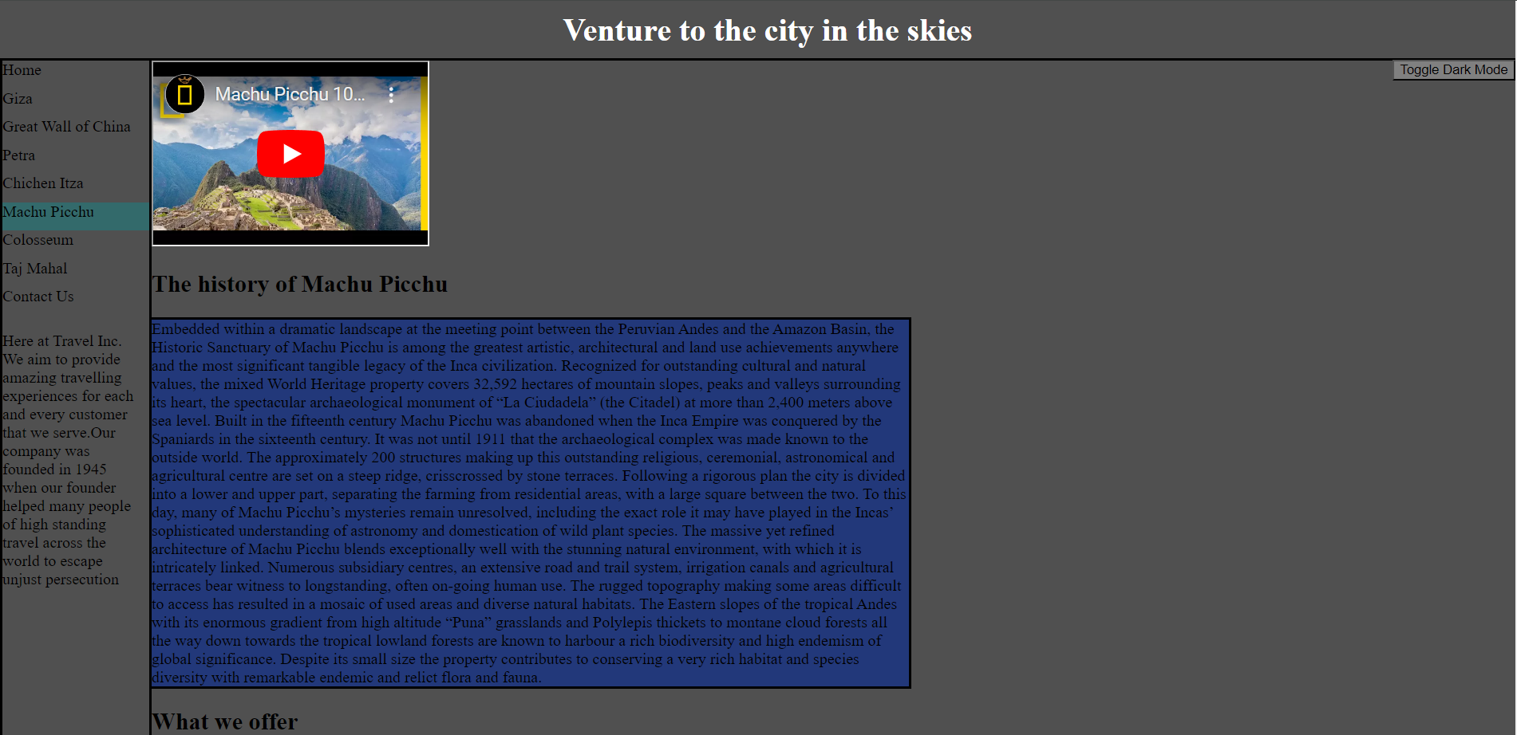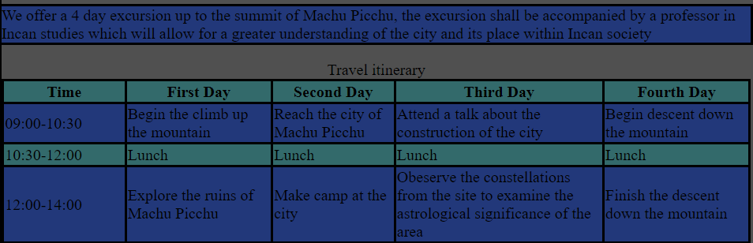

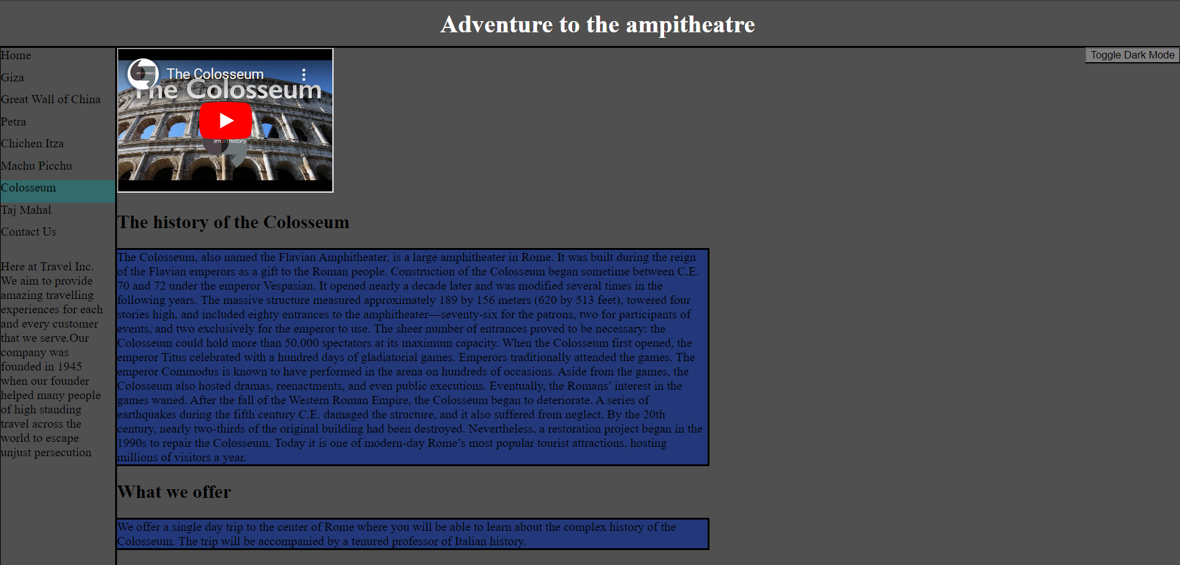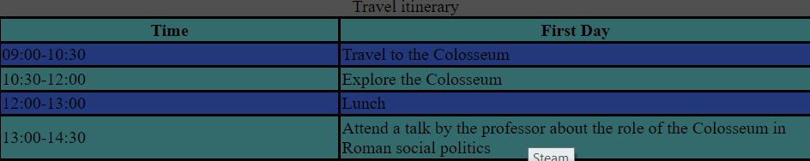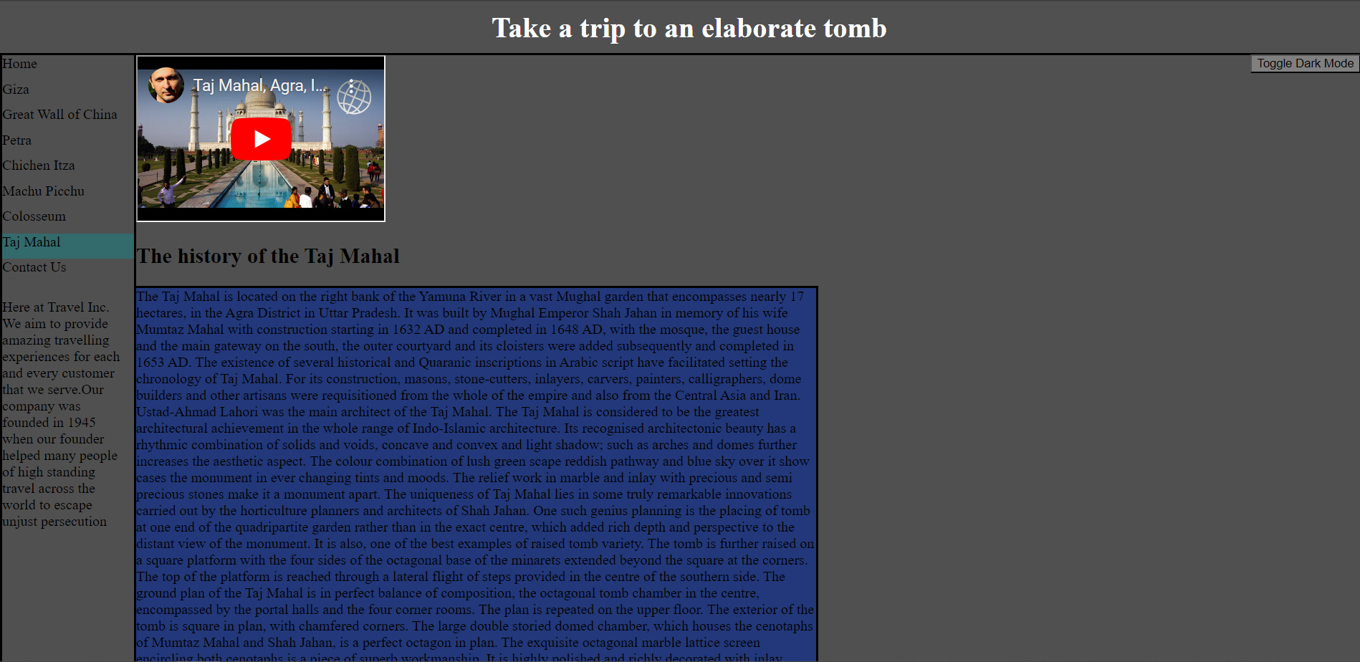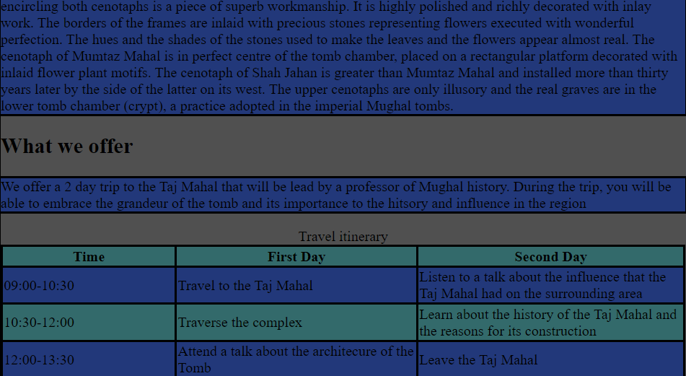Contact Page: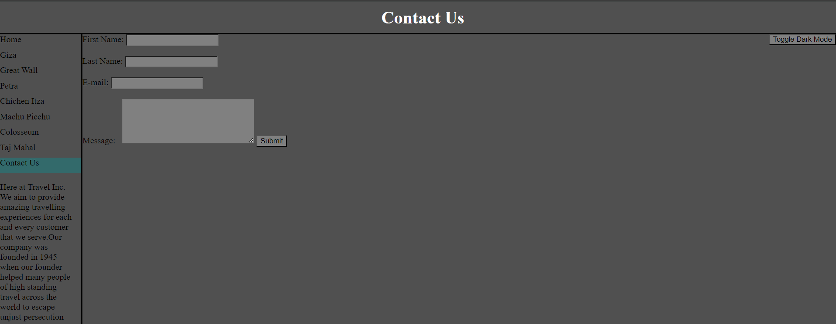

# Testing:

|  |  |  |  |  |
| --- | --- | --- | --- | --- |
| Test Number: | Test Description | Expected Result | Outcome: | Retest? |
| 1. | Test Giza link from homepage | Pyramids of Giza page expected to open | Pyramids of Giza page opened | No |
| 2. | Test Great Wall link from homepage | Great Wall of China page expected to open | Great Wall of China page opened | No |
| 3. | Test Petra link from homepage | Petra link expected to open | Petra page opened | No |
| 4. | Test Chichen Itza link from homepage | Chichen Itza page expected to open | Chichen Itza opened | No |
| 5. | Test Machu Picchu link from homepage | Machu Picchu page expected to open | Machu Picchu opened | No |
| 6. | Test Colosseum link from homepage | Colosseum page expected to open | Colosseum page opened | No |
| 7. | Test Taj Mahal link from homepage | Taj Mahal page expected to open | Taj Mahal page opened | No |
| 8. | Test Contact Us link from homepage | Contact Us expected to open | Contact Us page opened | No |
| 9. | Test links from information pages back to home page | Home page expected to open | Home page opened | No |
| 10. | Test the link to the next information page from the previous one | The next information page is expected to open | For each information page the subsequent information page opened | No |
| 11. | Randomly test the links from random pages | The randomly selected page is expected to open | Every time a random page was opened, no issues were present. | No |
| 12. | Test the dark mode on the Home page | The dark mode should toggle on and off | The dark mode switched each time it was clicked | No |
| 13. | Test the dark mode on the information pages | The dark mode should toggle all elements to the selected colours | All elements were successfully switched | No |
| 14. | Test the dark mode on the contact page | All elements should change colour | Dark mode worked successfully | No |
| 15. | Test the user’s ability to type in their details to the contact boxes | The user should be able to input text into the text boxes | The user could input text into the First name, Last name and E-mail fields | No |
| 16. | Test that the message box can take input from the user | The user should be able to input a message into the message box | The user could input a message in the message box | No |
| 17. | Test that the submit button wouldn’t work if no message was sent | If the user tries to submit the message when it is empty an alert should pop up to tell them to fill the box | When submitting without having a message the alert appeared informing about how there has to be a message | No |
| 18. | Test if the submit button works if everything has been filled in | When the message box has text in it, when submitting an alert should pop up accepting the message | The correct alert appeared when submitting with the correct conditions | No |
| 19. | Test if the videos in the information pages work | When clicking on the videos embedded in the information pages, they should play | All the videos played as expected | No |
| 20. | Test if the hover affect on the navigation buttons works. | When hovering over non-active buttons they should become a different colour | When hovering over the buttons they became the assigned colour | No |

# Evaluation:

My website is a product of its maker. This was my first foray into developing a whole website by hand, as previously any HTML, CSS, and JavaScript that I had done was on a smaller scale and hence any complex systems were not implemented, and no consideration was made to the user experience. The creation of this website was not as arduous as once thought as I was able to utilise simple stylistic choices to limit the user expectation whilst making the website seem complex. The website has many strengths but one critical weakness that I could not address. One of the many strengths of my website was the navigation bar and its ease of use as the user had only need to click on one of the labelled buttons to any page within the website. This would allow any user or stakeholder to navigate easily without having to traverse linearly and so if they already knew what page they wanted to go to they would be able to get there easily. The simple design of the website adds to it rather than detract as it allows for the actual content of the website to take the foreground. The major weakness of the website is that there is no connection between the website and a database for the users to make a booking with. This could have been created with the use of PHP to connect the website to a MySQL database, but I believed this to be too much work for a simple mock NEA and the time required for me to learn a new language would be cumbersome to my overall NEA. This is the most singular problem of my website as everything that I have set out to accomplish has been done and works successfully. In the future, the main area of improvement would be the implementation of a database with the use of PHP to link the website to a MySQL database, this would require at least rudimentary knowledge of PHP, which is syntactically and morally corrupt, not much knowledge of MySQL is required as SQL is not hard to learn or use, and I already have a handful of knowledge regarding SQL and hence the greatest effort would be expended on having to learn PHP. Other than the linking to a database using PHP, a wrapper would need to be created to allow the user to interact with the database with their own primary key. This would require validation to ensure that the user could not interact with the database for an ID that is not theirs. Validation can be done with JavaScript libraries, but the UI would have to be made from scratch as a framework such as HTMX with tailwind would add unnecessary complexity.